Lesson 10 E&c build a lighthouse | 

AIM OF THE LESSON

During this lesson students will:
- Apply their understanding of simple circuits, batteries, copper wire and a globe to construct a lighthouse.
- Use conductors and switches to construct a lighthouse.
- Design a simple pressure switch for the lighthouse circuit.


EQUIPMENT

Per Class
- Blu-tac, Glue, sticky tape
- Scissors
- Elastic bands, pegs

Per Group
- 2 D batteries (1.5 volts)
- 3 lengths (15cms) of insulated copper wire with about 1cm of insulation removed at each end
- 1 small globe (have some spares)
- 12 sheets of A4 paper (recycled)
- 1 m of alfoil
- paper clips or split pins

Preparation
  - Nil

Safety
  - Nil

Background Information for teachers

Lighthouse features
- A lighthouse is a building that was made to guide ships. The most important part of a lighthouse is the light that it casts at night. Sometimes lighthouses guide ships to a port or harbour. Other times they guide ships away from a hazard. Sometimes they do both.
- At night, lighthouses guide ships with their light. All ships have a book, called a Light List, which tells them the characteristics of lighthouses. If a mariner saw a white light flashing every seven-and-a -half seconds, he could look it up and find out which lighthouse it is.
- During the day, lighthouses guide ships with a day mark. A lighthouse's day mark is simply its size, shape and colour.

Lighthouses in Western Australia

A few of the well known light houses in WA include:
      - Rottnest Island
      - Cape Naturaliste, Dunsborough
      - Cape Leeuwin, Augusta
      - Fremantle North Mole (red)
      - Cape Leveque
      - Fremantle South Mole (green)

Diagram of Lighthouse
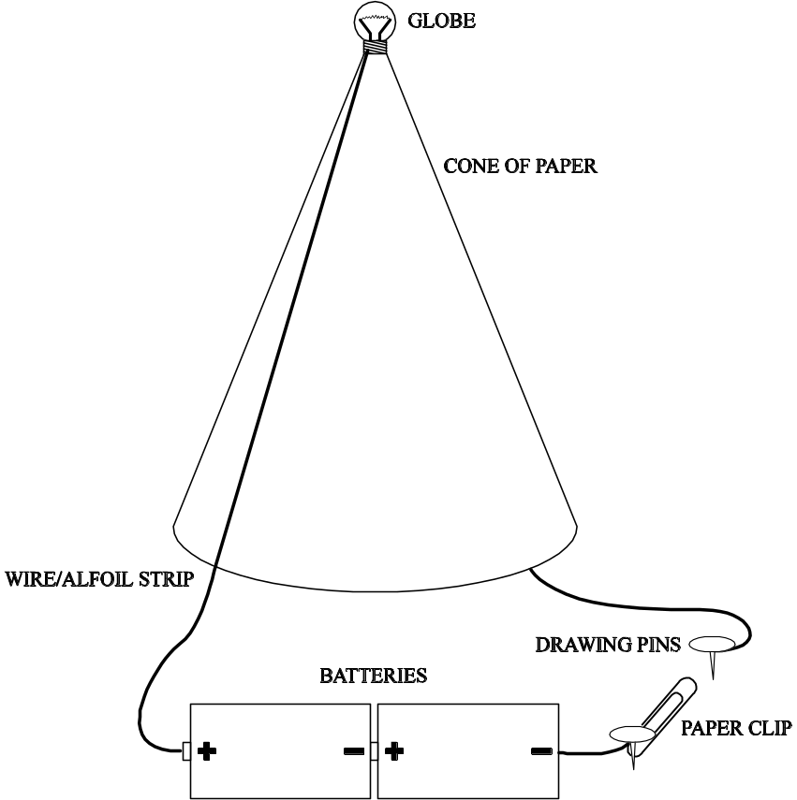

- The two main challenges are:
  - Making the tower 50cms and free standing. A tripod shape with three legs also works well. These legs can be made of rolled up paper.
  - Making the circuit from the battery at the bottom of the lighthouse to the globe at the top.


Lesson Outline

1. Introduction (Engaging Students)
- Draw a sketch map of Western Australia or Australia on the board or use a chart. Ask students to mark on the map a lighthouse they have visited or know of. Some key ones are listed in the background knowledge section.
Why are lighthouses important?
How could you use your knowledge of circuits to build a lighthouse? | They guide ships into ports or they indicate where dangerous areas are.  A globe, battery and wires could be used to set up a circuit to the top of a lighthouse.

2. Activities and Strategies
- Discuss the aim and equipment.
- 10 minutes: students discuss in groups what they will do and drawing their design
- 40 minutes: Students construct a simple lighthouse using:
- 2 batteries
- 1 globe
- 12 sheets of A4 paper (rolled up as the lighthouse)
- a combination of two split pins and a paper clip as a switch
- copper wire

- The lighthouse must: (Write these on the board)
  - be free standing
  - be a minimum of 50cm high
  - have a working light at the top
  - have an on/off switch
  - have all wiring and the switch on the outside of the light house
  - have a switch to break the circuit
  - be a complete circuit

    - Groups to demonstrate their working lighthouses.
3. Focus Questions (Explain and Elaborate)
What problems did you have and how did you overcome them?

What would you do differently next time? | Various.  Various.

4. Reflection
- Each group completes a self-appraisal of their lighthouse and suggests new design possibilities.


Extension Activities

- Use Morse Code to give out a signal from your lighthouse.
- Improve the design of your lighthouse by making changes to the design.


Links to other learning Areas

- On a map, mark all the lighthouses found in Australia.
- Research what Morse Code has been used for.
- Read a novel based on a lighthouse.
- Build and decorate a lighthouse which can then be wired up to work.

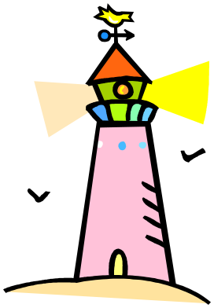
ACTIVITY 10 BUILD A LIGHTHOUSE

Aim (What are we going to find out?)

Equipment (What do I need to complete the task?)

2 batteries
1 globe
12 Sheets of A4 paper
A combination of two split pins and a paper clip as a switch
Copper wire

Method (How is the task to be done?) Draw a diagram of your design.

Results (What did I observe?)

Conclusion (What changes would you make to improve your lighthouse?)

